Helps us Save our Democracy!
Our mission is to make young voters in swing states understand how their vote affects the future of our country.
Do You Want to Live in This America?

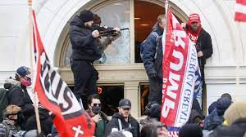

Or This America?
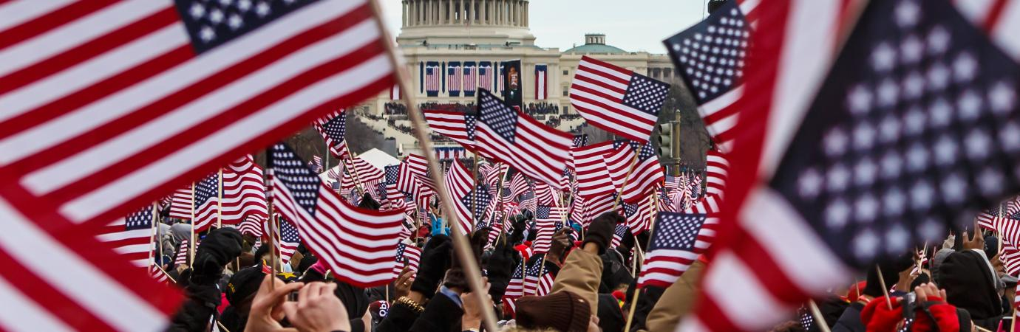

Donate Now!
Fundraising Goal: $30,000
Learn more about our mission:
www.abc.com

Save our Democracy Project

Our Democracy is Under Attack!

The United States is on the verge of turning into an extremist dictatorship, where millions of people blindly support a group of unscrupulous politicians who will do whatever it takes to hold on to power.
The most troubling aspect of these trends is the indifference of millions of Americans, especially young voters, to the seriousness of this threat.
If we don’t educate our youth on the importance of being well informed and of carefully choosing their candidates at election time, we face the risk on living in an increasingly radical, violent, and unstable society.
We want to do something about this critical danger, and you can help us!
Be a Part of Our #fight

A Typical Young Swing Voter
Jim is a recent high school graduate who grew up in a working-class family in Ohio. His political views have been shaped by many different viewpoints:
His parents hold traditional conservative views on the right to own guns and to limit the size and influence of government.
Jim’s friends and acquaintances include minorities and liberals who grew up in single-parent families, and depend on government assistance to survive.
Considering the conflicting political opinions that Jim has been exposed to, it’s understandable that his own views may be unclear, or he may feel disconnected from the extreme anger and fighting around him.
Jim is an example of the undecided voter we want to reach out to.
Our Goal

Through this project we want to counter the lack of real work opportunities often experienced by this youth community and allow them to realize their full potential.

Our goal is to make young voters in swing states understand how their vote affects the future of our country.

Our goal is to start a social media campaign targeting young voters living in swing states.
This campaign aims to educate our youth on how political views are formed, and how they subconsciously affect our voting behavior during elections.
When young people understand that it’s important to critically think through their political beliefs, rather than blindly going along with the crowd, they will realize the weight that their vote has in determining the future of society.
Through this project we hope to make young voters aware that they are entitled to their own political opinions, even if they differ from their family and friends.
This should encourage at least a portion of our targeted audience to resist peer pressure and vote for their favorite candidates.

Our Plan of Action

I will start creating website and social media content to educate the public about the need to get more young people involved in civic activities, especially voting.
Initially, volunteers will help with planning and creating online content. I also plan to share my blog posts with influential people on social media sites.
My campaign will last from July 2022 to August 2022. This will allow us to generate the funds needed to start a social media campaign in September, before the election in November.
I believe there are enough people who are aware of the need to mobilize more voters in order to help elect leaders who truly care about our needs and values.

Help Us to Educate the Next Generation of Voters
Our young citizens are living in one of the most divisive, confusing times in America’s history. It’s almost impossible to find unbiased information on how to address this threat to our country’s future.
We believe that today’s generation, regardless of cultural background and geography, is open to balanced debate and information that can help them create a better society for all citizens.
Unfortunately, they need unbiased guidance and education in order to have a more open attitude. That’s what this project intends to do.
By making a financial contribution you can help us to:
- Create a website focused on educating young people about the political system, how to find information on election candidates, how to spot biased misinformation, and how to become civically active
- Hire freelance writers to create social media content targeting young voters who live in electoral swing states
- Fund online ads inviting our target audience to visit our website
This is Urgent!
We need to generate $30,000 by August. This will allow us enough time to plan and implement our campaign before the coming election in November.

www.abc.com

